Workshop 3 More Decisions and Introduction to Variables
In this session we shall extend what we looked at in the last class related to making decisions. As you will see shortly there is potentially a lot more that you can do when it comes to using the If-then control structure.
We will also introduce a really important concept in pretty much all programming languages, which is the idea of variables.
Let’s start with variables first.

Variables
Variables are a really important concept in the majority of programming languages and the same is true of using Scratch.
There is one really big issue with variables to keep in mind though, which is that the majority of the population find it hard to wrap their brains round the concept, if you struggle with the idea of variables please remember that everybody else does too!
The idea of variables isn’t difficult, but there are some rules associated with them that can trip us up.
“Variables are named invisible boxes in the computer’s memory that allow us to store a unit of potentially changeable data for a limited duration.”

Variables, Creation and Assignment
One of the big problems with understanding how variables work is that they exist internally to the computer just like boxes that we can’t see. This often means that we need to keep track in our head what is going on with the data as our program runs. This requires us to think like a computer, something that doesn’t come naturally to human beings.
Scratch is nice to us in that the default setting is to display the variable’s data on the screen during program execution...
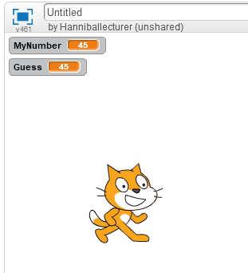

Some Points to Consider about Variables...
- Within the same program we only need to create a variable once, prior to use
- We may control if a variable applies to the entire script or just to the sprite in which it is created
- If a variable has not been created we won’t be able to use it in our scripts
- Variables need to have a name by which we reference the variable
- It is a good idea to give variables meaningful names to help us remember what they do
- A variable name may only be used once in the same program or sprite
- Variables store a single unit of data; if we give the same variable new data then the previous data is overwritten
- Keeping track of data in our head gets more complicated as the script grows in complexity; don’t be afraid to use bits of paper to keep track of things (all good programmers do this!)
- In programming creating a variable is called “declaration” and setting the value of a variable is called “assignment”

If-Then-Else and Nested If Statements
Having looked at variables let’s take a look at extending our knowledge of if statements.
We have already seen a simple if statement, in the slug racer game like so...
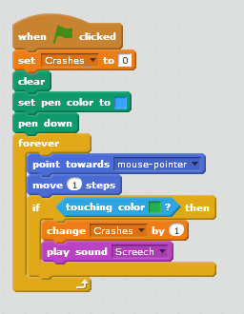
In this case we deal with the situation of “if the slug touches the colour green, then increase the number of recorded crashes and play the screech sound!” (Notice that in this example we use a variable called “Crashes”!)

The Else Instruction
We use the else instruction when we want a catch-all for a decision when the main condition isn’t true.
Take a look at the following if-then-else block...
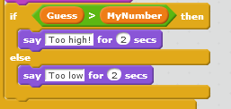
In this case the decision asks the question is the value of the variable “Guess” greater than the value of the variable “MyNumber”? If it is then display the message “Too high” for 2 seconds, otherwise display the message “Too low” for 2 seconds.
Let’s have a go at putting this all together into a full script.

Number Guessing Game
To bring all of this together we will have a go at creating a guessing game in Scratch.
The rules are: the computer thinks of a number between 1 and 100 and the user gets to guess the number repeatedly until they get it right!
First thing to keep in mind: If you find the final problem too difficult at first then try to create a stripped down version of the code.
What’s the least we can get away with in our algorithm to make it a working game?
- Computer thinks of a number
- User guesses number and types in
- Computer checks to see if number is current
- If so – well done, end of game – THIS IS INTRODUCING THE IF-ELSE
- If no – sorry, try again.
- Go back for another guess
The script may look something like this...
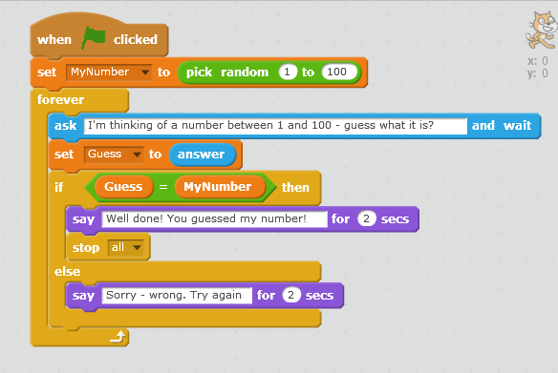
What are the limitations of this algorithm?
Very hard! Literally would have to go through all numbers until you got it right
So… introduce the idea of better quality feedback - hints (higher and lower, like hot and cold in hunt the thimble) – example of instant user feedback to help the user/learner – very powerful means of learning
Needs us to make our right and wrong checking a bit more complex – need to introduce a nested if-else
We also need to use another mathematical operator (greater than)
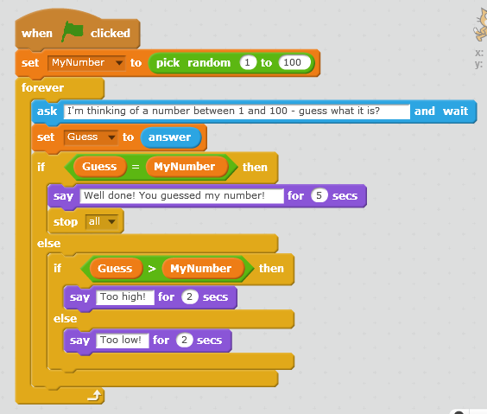
This works but it’s a bit boring… Not much of a reward for getting it right, or risk to getting it wrong.
So… let’s make it more exciting
Let’s make it so that when you get the number wrong, there is an annoying buzz sound and when you get it right, there is a ‘triumph’ sound and the cat does a cartwheel.
The sounds are easy (we did these last week) - although putting them in the right place can be tricky.
But the cartwheel is harder, requires using a new motion block ‘Turn’ and thinking about angles and division. (otherwise the cat cartwheels very slowly).
We end up with this:
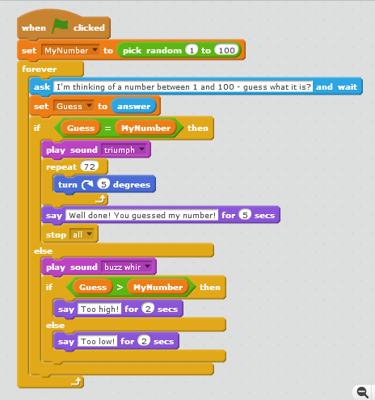
One extension can be to also say the number at the end so users are sure of what it was:
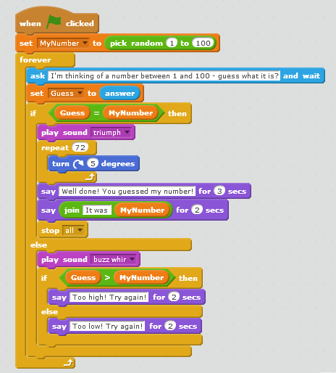
Need to use a ‘join’ operator and also remember the space after ‘it was’

